# [One Line, Please](https://compete.metactf.com/1337/problems" \l "problem1819)

Using ‘setspn’, create a PowerShell one-liner that lists the labs.local domain's service principal names.

## Solution:

setspn -T labs.local -Q */*

# [SUNBURST](https://compete.metactf.com/1337/problems" \l "problem9335) **[(solved by 133 teams)](https://compete.metactf.com/1337/problems" \l "problem9335)**

What is the name of the compromised DLL leveraged by Threat Actors in the SolarWinds supply chain attack?

The flag is the name of the DLL.

## Solution:

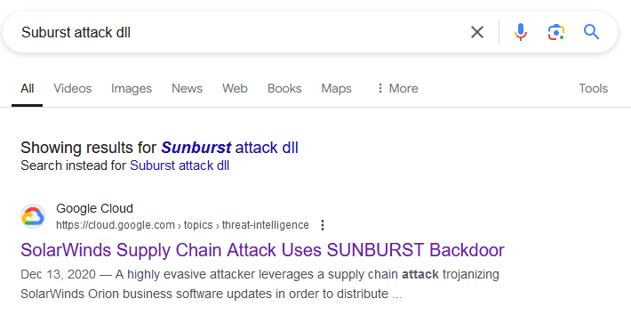

# [The Unforgettable Photocopier](https://compete.metactf.com/1337/problems#problem279)

Did you know that photocopiers often store a history of every document they print? In yet another security incident, someone seems to have printed out some company materials then walked out the door with them. We've already imaged the [photocopier hard drive](https://range.metaproblems.com/dc3bdd8c0d0d2fd9ae0edc87bc2d7674/photocopier.zip), now we need your team to dig through to find what documents were printed.

## Solution: